

GeoFarm-IS: An Agricultural Management System
with GIS and Predictive Farmer Analytics
_______________________________________________________
A Captone Project
Presented to the Faculty of
Bachelor of Science in Information Technology Program
Isabela State University – Ilagan Campus
City of Ilagan, Isabela
_______________________________________________________
In Partial Fulfillment
Of the Requirements for the Degree of
BACHELOR OF SCIENCE IN INFORMATION TECHNOLOGY
_______________________________________________________
By:
BERONIA, RENATO JR. P.
NOLEAL, CHARLES EDWARD C.
Adviser:
ORFEL L. BEJARIN, DIT
TABLE OF CONTENTS
Title Page i
Table of Contents ii
CHAPTER I – THE PROBLEM AND ITS BACKGROUND
Introduction 3
Objectives of the Study 5
Scope and Limitation 6
Significance of the Study 7
Review of Related Literature and Studies 9
Definition of Terms 12
CHAPTER II – TECHNICAL BACKGROUND
Conceptual Framework 15
Research Paradigm 17
System Architecture 18
Context Diagram (Level 0 & Level 1 21
Data Flow Diagram 24
Use Case Diagram 27
Entity Relationship Diagram 29
Database Schema 34
GANTT Chart 48
CHAPTER III – METHODOLOGY
Research Design 49
Research Participants 50
Data Gathering Procedure 50
Research Instrument 51
Statistical Treatment 52
CHAPTER I
THE PROBLEM AND ITS BACKGROUND

Introduction
Agriculture remains a vital sector in the Municipality of Tumauini, Isabela, serving as a primary source of livelihood for many of its residents. The municipality, situated in the fertile Cagayan Valley region, relies heavily on crop production, particularly rice and corn, as well as livestock raising as primary economic activities. Despite its agricultural significance, the administrative infrastructure supporting farmers has not kept pace with the demands of modern agricultural management.
The current process of farmer registration and data management within the Municipal Agriculture Office is largely manual, requiring farmers to fill out physical forms that are later encoded into spreadsheets. This approach is time-consuming, prone to data inconsistencies, and highly inefficient when retrieving or updating records—especially during peak transaction periods such as the distribution of seeds, fertilizers, and financial assistance. As a result, delays in processing and limited accessibility to organized information hinder both farmers and agricultural personnel from making timely and informed decisions.
In addition, the absence of an integrated information system limits the office's ability to effectively monitor and analyze key agricultural data such as land ownership, crop types, livestock inventory, and seasonal production trends. Without proper tracking and analytical tools, identifying farmers who are at risk of financial loss—referred to locally as "palugi"—particularly during unpredictable dry and wet seasons, becomes exceedingly difficult. This inability to proactively identify at-risk farmers reduces the Agriculture Office's capacity to intervene before losses become irreversible.
Existing solutions such as basic spreadsheet systems and standalone digital records provide minimal support for real-time monitoring, geospatial visualization, and predictive analysis, making them insufficient for proactive agricultural management. While some commercial farm management systems exist globally, they are often prohibitively expensive, not tailored to local LGU processes, and lack integration with Philippine agricultural policies and local government reporting requirements.
To address these multi-faceted challenges, this study proposes GeoFarm-IS, a Web-Based Agricultural Management System with Geographic Information System (GIS) and Predictive Farmer Analytics. The system aims to automate farmer registration through a centralized digital platform, generate QR codes for faster and more efficient transactions, and provide comprehensive tracking of farmer profiles and agricultural activities per season. Furthermore, GeoFarm-IS integrates geospatial mapping to visualize landholdings, crop distribution, and livestock inventory across the municipality, while predictive algorithms identify farmers who may be at risk of financial losses, enabling the Municipal Agriculture Office to intervene proactively.
By streamlining transactions and providing advanced monitoring capabilities, GeoFarm-IS offers a sustainable and mutually beneficial solution—empowering farmers while enabling the municipality to increase agricultural productivity and resilience. The system is designed to comply with pertinent Philippine agricultural policies including Republic Act No. 8435 (Agriculture and Fisheries Modernization Act) and the Registry System for Basic Sectors in Agriculture (RSBSA) guidelines.

Objectives of the Study
This study aims to develop a web-based Agricultural Management System with GIS and Predictive Farmer Analytics (GeoFarm-IS) that digitizes farmer registration, enables geospatial monitoring of agricultural activities, and provides predictive analytics to identify farmers at risk of financial loss for the LGU Agriculture Office of Tumauini, Isabela.

Specifically, this study seeks to:
- Determine the problems involved in the existing manual farmer registration and data management system of the Municipal Agriculture Office of Tumauini, Isabela.
- Develop a web-based Agricultural Management System (GeoFarm-IS) that contains the following modules:
  - Centralized Farmer Registry with comprehensive farmer profiles (personal information, landholdings, crops per season, livestock inventory) and QR code generation for faster transactions;
  - Seasonal Agricultural Tracking module that monitors farmer activities, crop production volumes, and inputs across dry and wet seasons;
  - Geographic Information System (GIS) Mapping module that visualizes farmer land locations, crop distribution, and livestock density across the municipality;
  - Predictive Farmer Analytics module that identifies farmers on track to experience losses ("palugi") based on seasonal data, enabling early intervention; and
  - Financial Assistance and Livestock Tracking module that monitors aid distribution and livestock inventory for each farmer.
- Test the developed system using:
  - Alpha testing—conducted by the development team to identify and resolve technical defects; and
  - Beta testing—conducted by selected Agriculture Office staff and farmers in a real-world operational environment.
- Evaluate the developed system using the ISO 25010 quality standard in terms of:
  - Functional Suitability—completeness and correctness of system features;
  - Usability—ease of use for staff and farmers; and
  - Reliability—system stability and consistency during peak usage periods.

Scope and Limitation
This study covers the development and full implementation of GeoFarm-IS exclusively for the LGU Agriculture Office of Tumauini, Isabela. The system encompasses five (5) primary modules: (1) Centralized Farmer Registry with QR code generation and printable ID cards, (2) Seasonal Agricultural Tracking for monitoring crop and livestock activities across dry and wet seasons, (3) GIS Mapping for visualizing farmer land locations, crop distribution, and livestock density across the municipality, (4) Predictive Farmer Analytics for the early identification of at-risk farmers ("palugi"), and (5) Financial Assistance and Livestock Tracking for monitoring government aid distribution.
The system will be web-based, accessible via desktop and laptop computers with internet connectivity. Development will utilize Laravel 12 (PHP) for the backend, MySQL with PostGIS extensions for the database, Leaflet.js or OpenLayers for GIS mapping functionality, and JavaScript-based libraries including Chart.js and Recharts for data visualizations. Evaluation will be governed by ISO 25010 standards, focusing specifically on functional suitability, usability, and reliability.
This study is delimited to the Municipality of Tumauini, Isabela only, and does not extend to other local government units. The system will not include dedicated native mobile applications (iOS or Android), though it will feature a mobile-responsive interface for basic viewing. The predictive analytics algorithm will initially employ rule-based and statistical approaches—such as trend analysis and threshold-based alerts—rather than complex deep learning or machine learning models, although the architecture will accommodate future ML integration. The GIS module will rely on manually mapped or GPS-collected land coordinates rather than real-time satellite imagery. The system will not integrate directly with external government information systems such as the DA's RSBSA database or the PCIC database, though data export features will be provided. The study will also not encompass farm input supply chain management or live market price monitoring. Evaluation will be based on feedback from Agriculture Office staff and a purposive sample of farmers, not a comprehensive municipal-wide survey.

Significance of the Study
This study is significant in demonstrating the practical application of information and communication technology to address long-standing inefficiencies in local agricultural management. The developed system is expected to benefit the following stakeholders:

Farmers of Tumauini, Isabela – Farmers will receive QR-coded identification cards enabling faster, paperless transactions with the Agriculture Office. The predictive analytics feature will trigger early interventions when individual farmers are identified to be at risk of financial losses, potentially preserving their livelihoods and improving household food security.
LGU Agriculture Office Staff – Agricultural staff will benefit from a centralized, automated system for managing farmer registrations, tracking seasonal agricultural data, monitoring livestock, and generating official reports—effectively replacing manual, Excel-based processes and reducing hundreds of administrative work hours annually.
Municipal Agriculturist and Planning Officers – These officers will gain access to real-time GIS visualizations of agricultural land use, crop distribution, and at-risk farmer identification, enabling evidence-based decision-making and the timely design of proactive intervention strategies.
Office of the Mayor and Municipal Council – Local officials will receive accurate and current data on agricultural productivity and farmer welfare to support policy-making, budget allocation, and agricultural program planning.
Department of Agriculture (DA) Regional Office – As an indirect beneficiary, the DA regional office can utilize consolidated farmer profile data, production trends, and intervention needs reported by the system for regional agricultural planning and program implementation.
Philippine Crop Insurance Corporation (PCIC) – Accurate farmer and crop data maintained in GeoFarm-IS can streamline insurance enrollment and claims processing for farmers affected by calamities or production losses.
Future Researchers and Students – The system and its full implementation serve as a replicable case study for ICT applications in local agricultural management, GIS integration for rural development, and the use of predictive analytics for social good in the Philippine context.
Consumers and the General Public – By supporting farmers in mitigating losses and increasing production efficiency, GeoFarm-IS indirectly contributes to food security and price stability within the municipality and surrounding communities.

Review of Related Literature and Studies
A growing body of research supports the integration of information technology into agricultural management at the local government level. This chapter synthesizes relevant literature and studies under thematic areas that directly inform the development of GeoFarm-IS.

Agricultural Information Systems and Farmer Registries
The digitization of farmer records has become a priority across developing economies. Delos Reyes and Sanchez (2022) demonstrated the feasibility of web-based farmer registry systems for Local Government Units in the Philippines, highlighting significant reductions in processing time and data inconsistency when digital platforms replaced manual forms. Similarly, Santos et al. (2023) found that the implementation of RSBSA-compliant digital registration in selected Philippine LGUs resulted in more accurate farmer profiling and improved access to government agricultural programs. These findings directly support the rationale for transitioning the Municipality of Tumauini from spreadsheet-based records to a centralized digital registry.
Rivera et al. (2023) specifically examined the design of farmer profiling systems for municipal agriculture offices and identified QR code integration as a high-impact feature for streamlining field transactions. Reyes et al. (2020) provided empirical evidence that QR code-based farmer identification systems significantly reduced transaction time in government service delivery. These studies collectively validate the core Farmer Registry and QR Code modules of GeoFarm-IS.

Geographic Information Systems in Agriculture
The application of GIS technology in agricultural monitoring is well-established in literature. Longley et al. (2022) provided foundational principles of geographic information science and systems that underpin spatial analysis methods employed in GeoFarm-IS. Sarmiento et al. (2022) conducted geospatial analysis of crop distribution and productivity in Isabela Province specifically, demonstrating the applicability of GIS tools at the provincial and municipal scale in the region.
Corpuz and Lontoc (2021) developed a web-based GIS platform for agricultural resource management in Philippine LGUs, reporting that Leaflet.js and OpenLayers are optimal open-source mapping libraries for resource-constrained environments such as municipal offices. Their findings directly informed the GIS technology stack selection for GeoFarm-IS. De la Cruz and Ramos (2023) further established best practices for GIS-based mapping of agricultural land use in the Philippines, including GPS-based coordinate collection methods that inform the data collection approach for GeoFarm-IS's mapping module.

Predictive Analytics in Agriculture
Predictive analytics in agriculture has emerged as a critical tool for early warning and risk management. Dela Peña et al. (2022) developed a farmer risk prediction model using historical agricultural data in the Philippine context, demonstrating that statistical trend analysis and threshold-based alerts are viable methods for identifying farmers susceptible to financial losses—validating the initial methodology chosen for GeoFarm-IS's predictive module. Garcia and Santos (2021) applied data mining techniques to identify at-risk farmers in government agricultural assistance programs, identifying key indicators such as declining yield-to-input cost ratios across consecutive seasons.
Lopez et al. (2023) examined machine learning approaches for predicting crop losses due to climate variability, finding that even simpler regression and threshold models can achieve actionable predictive accuracy when trained on local historical data. The World Bank (2022) reinforced the value of predictive analytics specifically for agricultural resilience in developing countries, recommending rule-based systems as practical entry points before more complex ML models are deployed—an approach reflected in GeoFarm-IS's architecture design.

Agile Software Development Methodology
The Scrum framework within the Agile SDLC has been widely adopted for iterative software development projects in academic and professional settings. Pressman (2022) outlined the principles of agile development that enable rapid, feedback-driven iteration suitable for systems where end-user requirements evolve during development—a characteristic of the GeoFarm-IS project given the ongoing consultations with the Tumauini Agriculture Office. Sommerville (2021) further elaborated on agile practices including sprint planning, daily stand-ups, and sprint reviews as mechanisms for quality assurance and stakeholder engagement.
The seven-sprint development structure proposed for GeoFarm-IS aligns with recognized agile best practices that ensure incremental delivery of functional modules, continuous integration, and structured testing at each phase of development.

Definition of Terms
The following terms are defined conceptually and operationally to ensure clarity and better understanding of this study:

GeoFarm-IS – Stands for Geographic Farm Information System. In this study, it refers to the web-based Agricultural Management System with GIS and Predictive Farmer Analytics developed for the LGU Agriculture Office of Tumauini, Isabela.
Geographic Information System (GIS) – Conceptually, a GIS is a computer-based system for capturing, storing, checking, and displaying data related to positions on the earth's surface (Longley et al., 2022). Operationally, in this study, GIS refers to the interactive mapping module of GeoFarm-IS built using Leaflet.js and PostGIS that visualizes farmer land locations, crop distribution, and livestock density.
Predictive Analytics – Conceptually, predictive analytics encompasses statistical and machine learning techniques that analyze current and historical data to make forecasts about future events (World Bank, 2022). Operationally, in this study, it refers to the rule-based and statistical algorithm within GeoFarm-IS that identifies farmers at risk of financial losses ("palugi") based on their seasonal production data.
Palugi – A Filipino/Ilocano colloquial term meaning "to incur a loss" or "to operate at a loss." In this study, it refers specifically to farmers who experience financial losses from agricultural activities within a given season, as identified by the GeoFarm-IS predictive analytics module.
QR Code (Quick Response Code) – A type of matrix barcode that can be scanned using a smartphone or scanner to quickly access encoded digital information. In this study, QR codes are generated for each registered farmer and printed on ID cards to enable fast, paperless transactions at the Agriculture Office.
RSBSA (Registry System for Basic Sectors in Agriculture) – A national farmer registration database mandated by the Department of Agriculture to establish a comprehensive registry of farmers and fisherfolk in the Philippines. GeoFarm-IS is designed to be compliant with RSBSA data requirements.
ISO 25010 – An international standard for systems and software quality models. In this study, it serves as the evaluation framework for assessing GeoFarm-IS in terms of Functional Suitability, Usability, and Reliability.
Seasonal Agricultural Tracking – In this study, this refers to the module within GeoFarm-IS that records and monitors farmer agricultural activities, crop production volumes, input costs, and yields across the dry season (November–April) and wet season (May–October).
PostGIS – A spatial database extender for PostgreSQL and MySQL that allows geospatial data types such as point coordinates and polygons to be stored, queried, and analyzed. In this study, PostGIS is used to store farmer landholding coordinates for GIS map rendering.
Agile SDLC (Software Development Life Cycle) – A software development methodology characterized by iterative development cycles (sprints), continuous stakeholder feedback, and incremental delivery of functional software components. In this study, the Scrum framework under Agile SDLC guides the development of GeoFarm-IS.

CHAPTER II
TECHNICAL BACKGROUND

Conceptual Framework
The conceptual framework of GeoFarm-IS is grounded in the Input-Process-Output (IPO) model, which illustrates the logical flow from system requirements through the development process to the final system outputs. This framework guided the entire system design and development trajectory of the study.
Input |  | Process |  | Output
Data Inputs  - Farmer Personal Information  - Farm Parcel Data (location, size, ownership)  - Crop and Seasonal Data  - Livestock Information  - Financial Assistance Data  System Requirements  - Laravel 12, React 18, Inertia.js  - MySQL with PostGIS  - Mapping Libraries (Leaflet.js / OpenLayers)  - Python for Predictive Analytics  Hardware Requirements  - Web Server (Cloud VPS / LGU Server)  - Desktop/Laptop Workstations  Knowledge Requirements  - GIS Principles  - Predictive Analytics Techniques  - Philippine Agricultural Policies (RA 8435, RSBSA) |  | (Agile Scrum-based System Development)  - Sprint Planning  - Iterative Development  - Daily Stand-ups  - Sprint Review & Retrospective  - System Testing (Alpha & Beta Testing)  - Evaluation using ISO 25010 (Functionality, Usability, Reliability) |  | - Functional GeoFarm-IS Web System  - Centralized Farmer Registry  - QR-Coded Farmer Identification  - GIS-Based Agricultural Visualization  Predictive Analytics Dashboard (Palugi Detection)  - Financial Assistance Tracking System  - Generated Reports and Analytics  - Technical Documentation

Feedback
Figure 1. Conceptual Framework of GeoFarm-IS (Input-Process-Output Model)

The INPUT component encompasses three categories of requirements. Software requirements include the core technology stack: Laravel 12 as the backend PHP framework, React 18 for the frontend, Inertia.js as the bridge layer, MySQL with PostGIS for geospatially-enabled data storage, Leaflet.js or OpenLayers for interactive map rendering, and Python for advanced predictive analytics processing. Hardware requirements include a web server hosted on a cloud VPS or LGU-managed server, as well as staff workstations. Knowledge requirements cover GIS principles, predictive analytics logic, and Philippine agricultural policies including Republic Act No. 8435 (AFMA) and RSBSA guidelines.
The PROCESS component follows the Agile Scrum methodology, organized into seven (7) structured sprints spanning sixteen (16) weeks. These iterative cycles include sprint planning sessions, daily stand-up meetings, iterative development of each system module, sprint reviews with stakeholder demonstrations to the Tumauini Agriculture Office, sprint retrospectives for process improvement, and comprehensive testing and evaluation against ISO 25010 standards.
The OUTPUT component consists of the fully functional GeoFarm-IS platform with all five core modules deployed and operational: the Centralized Farmer Registry with QR-coded farmer IDs, the Seasonal Agricultural Tracking system, the interactive GIS Visualization module, the Predictive Dashboard for "palugi" risk identification, the Financial Assistance and Livestock Tracking module, and comprehensive technical documentation including user manuals and system architecture records.

Research Paradigm
This study follows an Applied Research paradigm combined with the System Development Research model. Applied research is employed as the primary orientation because GeoFarm-IS is developed to solve a concrete, identified problem—the manual and fragmented nature of farmer data management at the Tumauini LGU Agriculture Office. System Development Research provides the structured framework for the iterative design, development, testing, and evaluation of the software system as the primary research output.
The study integrates quantitative evaluation through the administration of validated ISO 25010-based questionnaires to measure functional suitability, usability, and reliability. This mixed-orientation approach ensures that the research is both practically grounded in solving real operational problems and methodologically rigorous in validating the effectiveness and quality of the developed system.

System Architecture

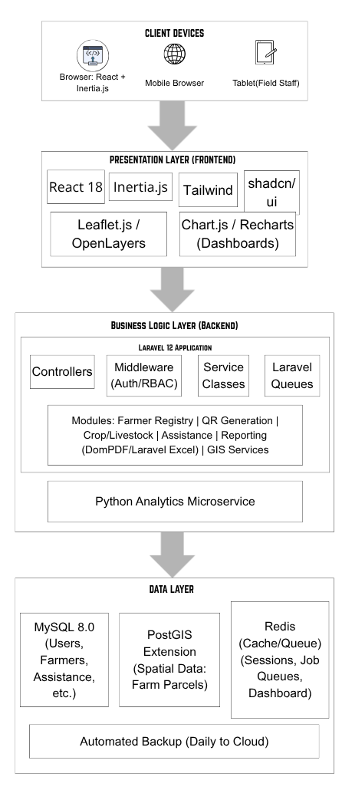
Figure 2. System Architecture — GeoFarm-IS
GeoFarm-IS follows a three-tier client-server architecture comprising the Presentation Layer, Business Logic Layer, and Data Layer. This architectural pattern ensures separation of concerns, scalability, and maintainability of the system.

Presentation Layer (Frontend): The user interface is built using React 18 with Inertia.js as the bridge to the backend, styled with Tailwind CSS and shadcn/ui component library. Interactive GIS maps are rendered using Leaflet.js or OpenLayers, while data visualizations are implemented through Chart.js and Recharts.

Business Logic Layer (Backend): Laravel 12 (PHP) serves as the primary backend framework, handling all application logic including farmer registration workflows, QR code generation via the Simple QR Code library, PDF report generation via DomPDF, Excel import/export via Laravel Excel, and authentication and role-based access control via Laravel Sanctum and Spatie Laravel Permission. Python may be integrated via API for advanced statistical computations in the predictive analytics module.

Data Layer (Database): MySQL serves as the primary relational database, extended with PostGIS for geospatial data storage and querying. Spatial data including farmer landholding coordinates (GPS polygons) are stored as GEOMETRY data types, enabling efficient spatial queries for GIS map rendering.

The system is deployed on a Linux-based web server (Apache/Nginx with PHP-FPM) hosted on a cloud VPS or the LGU's own server infrastructure. Version control is managed via Git and GitHub, with Agile project management supported through Trello or Jira boards.

Context Diagram
The Context Diagram (Level 0) presents GeoFarm-IS as a single system entity and illustrates its primary data flows with the external actors who interact with it. Figure 3 presents the Level 0 Context Diagram.

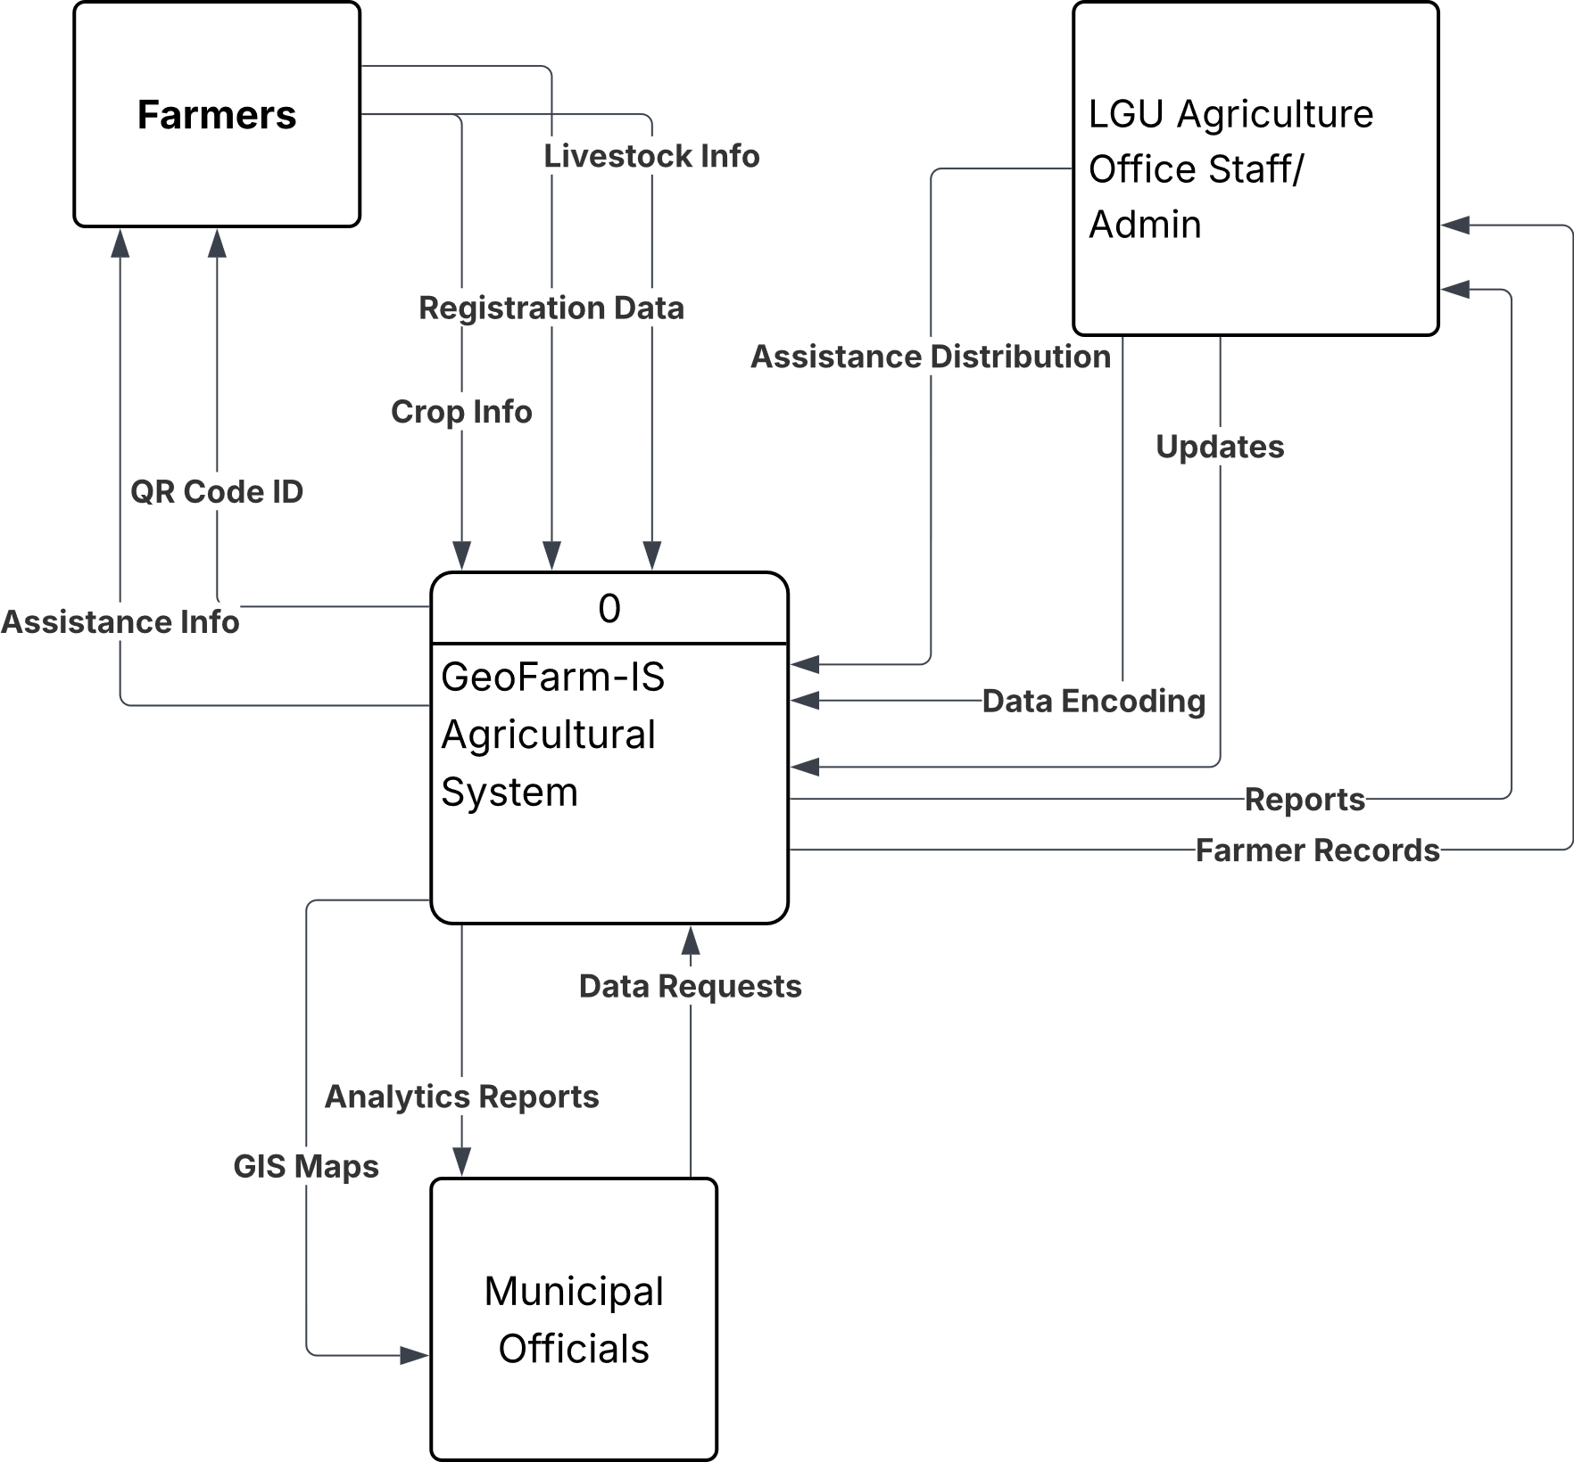
Figure 3. Level 0 Context Diagram — GeoFarm-IS

The four primary external entities interacting with GeoFarm-IS are: (1) the Farmer, who submits registration data and receives a QR-coded ID card; (2) the Agriculture Office Staff, who access the system to manage records and process transactions; (3) the Municipal Agriculturist, who queries the system for GIS maps, analytics, and statistical reports; and (4) the Mayor and Municipal Council, who receive consolidated agricultural data for policy and budget decisions.

The Level 1 Context Diagram decomposes the central GeoFarm-IS system into its six major internal processes, illustrating inter-process data flows and the connections to the shared MySQL/PostGIS database. Figure 4 presents the Level 1 Context Diagram.
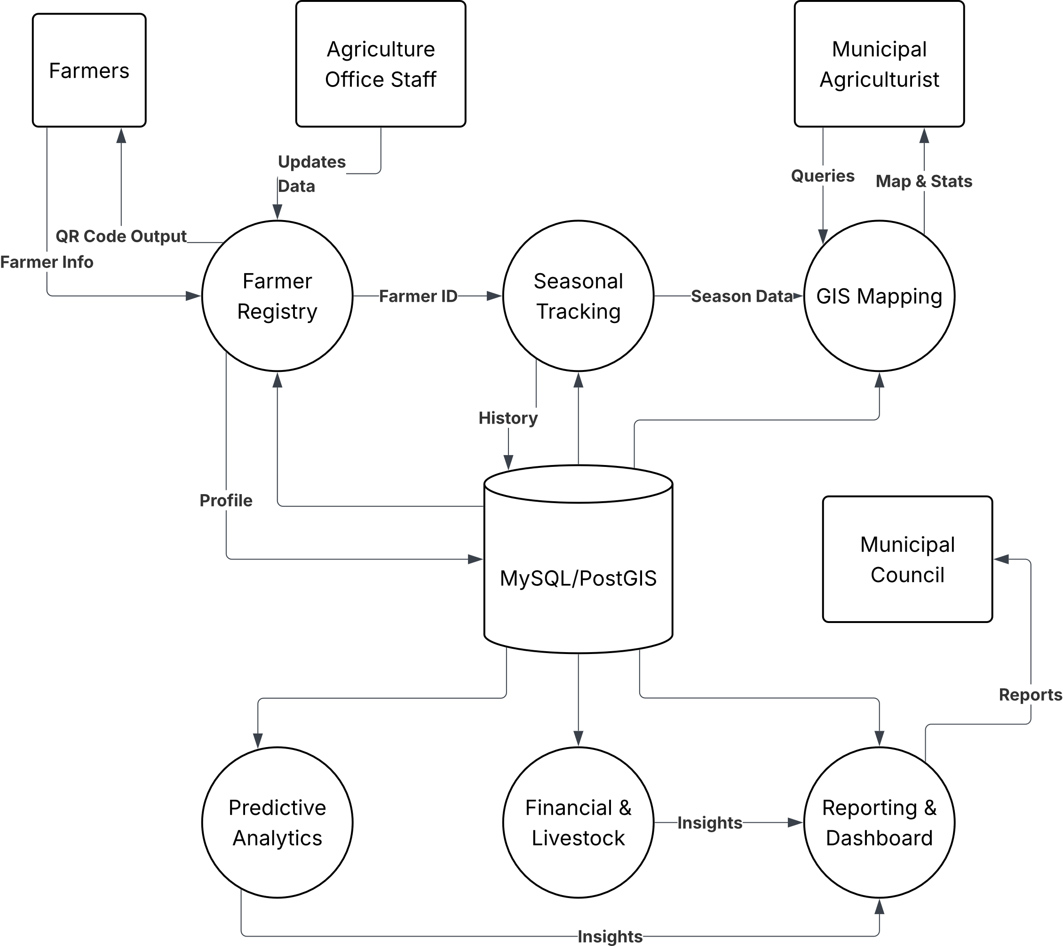
Figure 4. Level 1 Context Diagram — GeoFarm-IS Internal Processes

The six internal processes are: Process 1.0 – Farmer Registry, which handles farmer registration and QR ID generation; Process 2.0 – Seasonal Tracking, which records agricultural activities per season; Process 3.0 – GIS Mapping, which renders spatial visualizations from PostGIS coordinate data; Process 4.0 – Predictive Analytics, which computes risk scores from historical seasonal records; Process 5.0 – Financial and Livestock Tracking, which monitors assistance distribution; and Process 6.0 – Reporting and Dashboard, which generates outputs for all stakeholders. All processes read from and write to the central MySQL/PostGIS database.

Data Flow Diagram

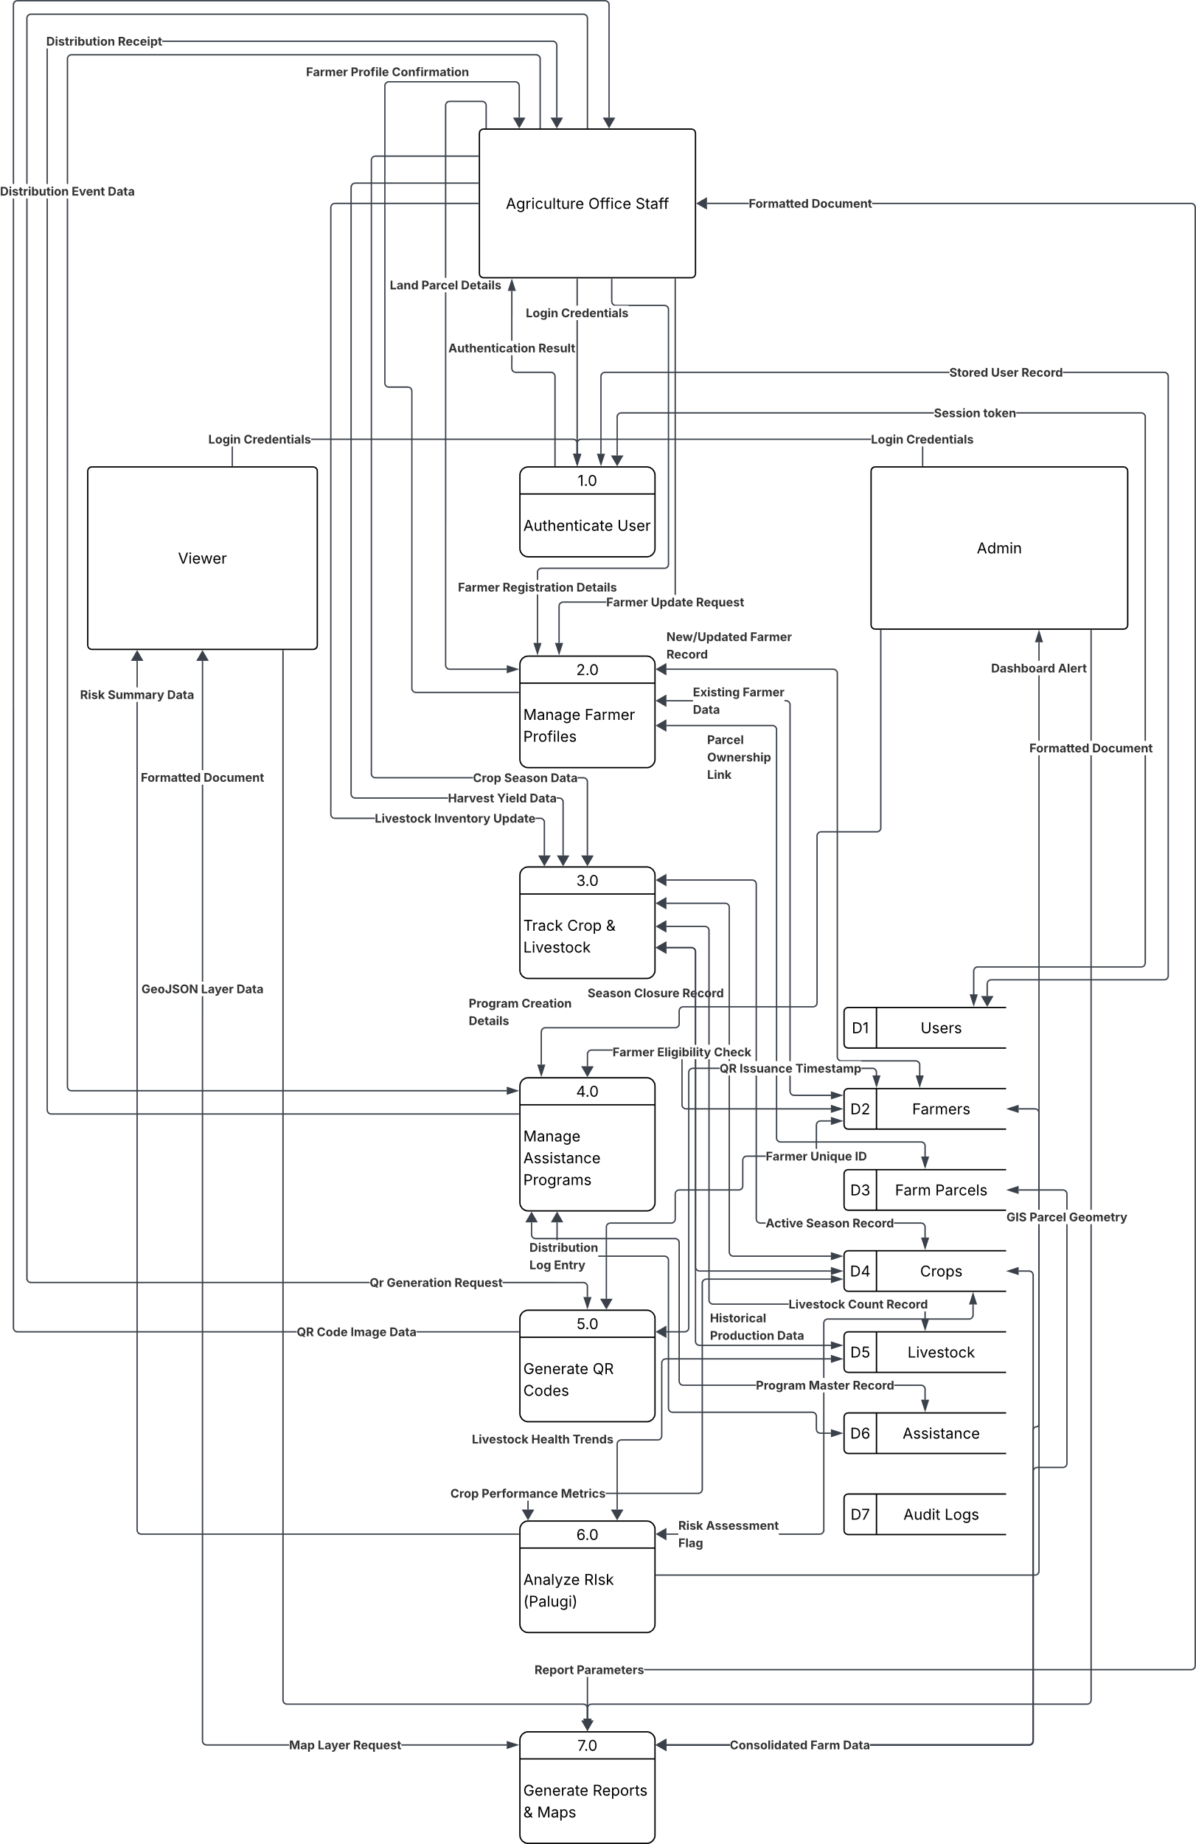
Figure 5. Data Flow Diagrams — GeoFarm-IS (Agriculture Staff, Admin/Super Admin, and Viewer)
The Data Flow Diagrams (DFD) for GeoFarm-IS map the movement of data through the system’s major processes, organized by user role. Three separate DFDs are presented to reflect the distinct workflows of each actor: Agriculture Office Staff, Admin/Super Admin, and Viewer (Municipal Agriculturist and Mayor/Council).
Agriculture Office Staff Data Flow (Figure 5a). Staff log in and are authenticated against the users table. Upon session creation, staff can register or update farmer profiles, which are validated and stored across the farmers, farm_parcels, and farm_types tables. When a farmer is saved, the system automatically generates a QR code stored in qr_code_path and made available for printing. Staff also record crop production data per parcel per season into crop_seasons, log livestock inventories across the livestock, large_ruminants, small_ruminants, native_pigs, swine_hybrid, poultry, and fishponds tables, enter tree crop records into tree_crops, and record assistance distributions in assistance_distributions. All actions are automatically written to audit_logs for accountability. Staff can generate PDF or Excel reports filtered by barangay, season, crop type, or risk level via DomPDF and Laravel Excel.

Admin / Super Admin Data Flow (Figure 5b). The Admin/Super Admin role has the highest level of system authority. After authentication against the users table with role verification via the roles and model_has_roles tables, the Admin can create, edit, and deactivate user accounts; oversee and correct all farmer and farm parcel records; create and manage financial assistance programs in financial_assistance and assistance_types; configure barangay-level allocations in assistance_barangays; and monitor predictive risk scores stored in the farmers table (risk_status field). All activity is logged in audit_logs with old and new data values in JSON format. The Admin also generates system-wide consolidated reports from all modules for administrative oversight and DA submission.

Viewer Data Flow (Figure 5c). The Viewer role, assigned to the Municipal Agriculturist and Mayor/Municipal Council, has read-only access. After authentication with role verification, Viewers query the system to access three outputs: (1) the interactive GIS map, which renders spatial data from the geom column of farm_parcels using Leaflet.js, displaying land polygons, crop distribution, and livestock density per barangay; (2) the Predictive Risk Dashboard, which reads the risk_status field in the farmers table to present a color-coded summary of farmers classified as low, medium, high, or critical risk; and (3) downloadable reports in PDF or Excel format covering farmer demographics, seasonal production summaries, and assistance distribution analytics. Viewers cannot modify any data in the system.

Use Case Diagram
The Use Case Diagram for GeoFarm-IS identifies three primary actor roles and their associated system interactions. Figure 6 presents the Use Case Diagram.

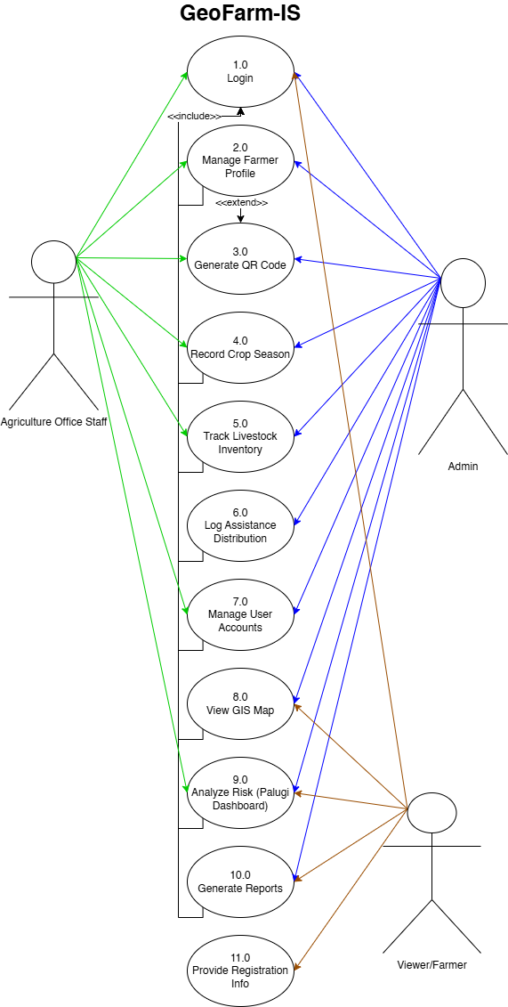
Figure 6. Use Case Diagram — GeoFarm-IS
Three user roles are defined within the system: (1) the Admin, who has full system access including managing user accounts and system settings; (2) Agriculture Staff, who handle the core operational functions of farmer registration, seasonal data recording, financial assistance tracking, and report generation; and (3) the Viewer role assigned to the Municipal Agriculturist and Mayor/Council, who have read-only access to GIS maps, predictive dashboards, and analytical reports. The system enforces role-based access control via Spatie Laravel Permission to ensure data security and appropriate access levels for each actor.

Entity Relationship Diagram
The Entity Relationship Diagram (ERD) defines the logical data structure of GeoFarm-IS as derived from the actual deployed database schema. The system database consists of twenty-eight (28) tables organized into five functional clusters: Core User and Authentication, Farmer Profiles and Land, Livestock and Aquaculture, Financial Assistance, and Audit and RBAC. The following core entities and relationships govern the database design:
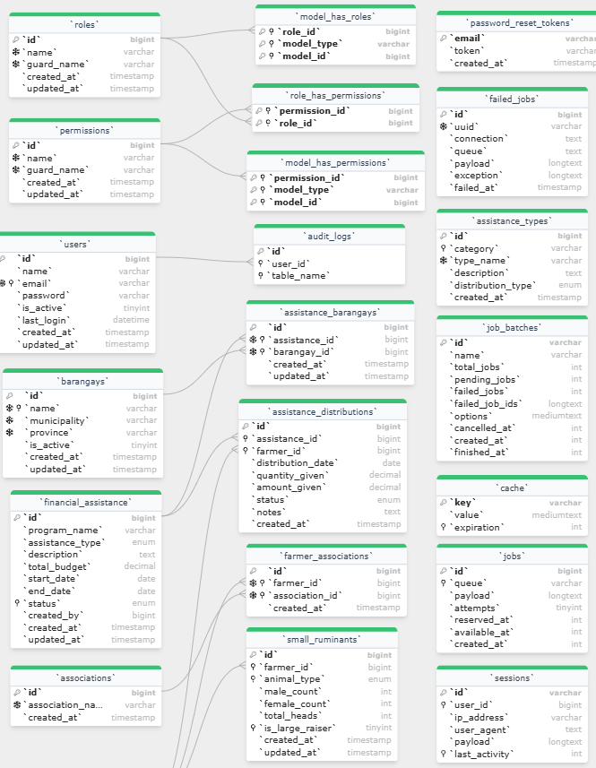
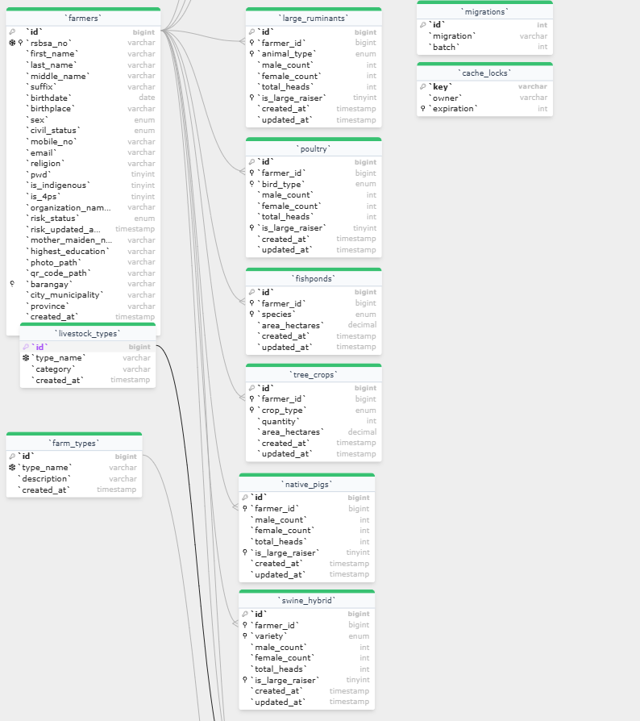
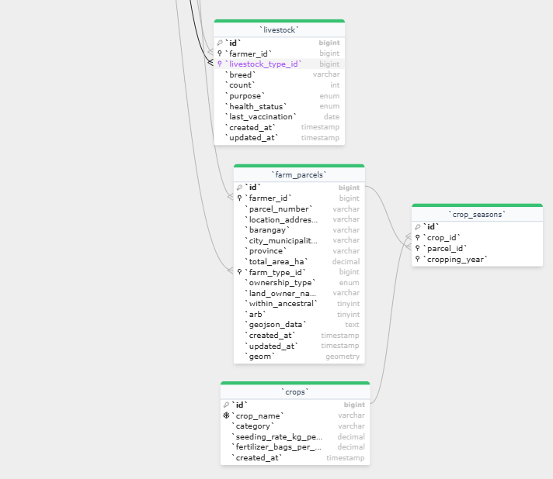
Figure 7. Entity Relationship Diagram — GeoFarm-IS
Core Entities and Relationships:
- users (1) to farmers (M): One authenticated user (Agriculture Staff) may register and manage multiple farmer records. Users are also linked to financial_assistance programs they create (created_by) and to audit_logs entries they generate.
- farmers (1) to farm_parcels (M): One farmer may own or cultivate multiple land parcels. Each parcel stores spatial boundary data in the geom (GEOMETRY) column for GIS rendering and references a farm_type from the farm_types lookup table.
- farm_parcels (1) to crop_seasons (M): Each farm parcel has multiple seasonal production records. Each crop_seasons record links to a crop in the crops lookup table and stores planting date, harvest date, yield in kilograms, and agricultural inputs in JSON format.
- farmers (1) to livestock sub-tables (M): Livestock inventory is tracked across six specialized tables linked to farmer_id: large_ruminants (cattle/carabao with male and female head counts), small_ruminants (goat/sheep), native_pigs, swine_hybrid, poultry (chicken/duck/goose/turkey with bird_type), and fishponds (species and area). A general livestock table using livestock_types is also maintained for flexible categorization.
- farmers (1) to tree_crops (M): Perennial tree crop inventories (mango, banana, cacao, pineapple) are stored per farmer with quantity of trees and area in hectares, enabling long-term agricultural asset tracking.
- financial_assistance (1) to assistance_distributions (M) to farmers (M): Each assistance program (linked to an assistance_types category) distributes aid to individual farmers through the assistance_distributions table, recording quantity given, amount given, date, and claim status (pending, claimed, forfeited). Programs can also be allocated at the barangay level via assistance_barangays, which links programs to the barangays reference table.
- farmers to associations (M to M): Farmers may belong to one or more cooperatives or irrigators associations via the farmer_associations pivot table, which links farmers to the associations reference table.
- roles to permissions (M to M): Role-based access control is implemented using three RBAC pivot tables. The model_has_roles table assigns roles to users, the role_has_permissions table assigns permissions to roles, and the model_has_permissions table allows direct permission assignments to individual users. The roles table defines system roles (Super Admin, Admin, Staff, Viewer) while the permissions table defines granular action-level access rights.

The ERD enforces referential integrity through foreign key constraints on all relational tables. The farm_parcels table includes a geom column of GEOMETRY type for storing GPS boundary polygons of each land parcel, enabling spatial join operations and choropleth rendering required by the GIS Mapping module. All livestock sub-tables (large_ruminants, small_ruminants, native_pigs, swine_hybrid, poultry) include a computed total_heads column automatically calculated from male_count and female_count to support livestock density analytics without redundant data entry.

Database Schema
The database schema of GeoFarm-IS is implemented in MySQL (MariaDB 10.4) and consists of twenty-eight (28) domain tables. Tables 2-1 through 2-28 present the schema for each entity in the system, grouped into six functional clusters. System-level Laravel framework tables (cache, jobs, sessions, migrations, password_reset_tokens, failed_jobs) are excluded as they do not store agricultural domain data.

Tables 2-1 to 2-28. GeoFarm-IS Database Schema
Table 2-1. Table for users Information
Table: users
Field Name | Data Type | Description
id | BIGINT UNSIGNED PK | Auto-increment primary key
name | VARCHAR(100) | Full display name of the user
email | VARCHAR(100) UNIQUE | Login email address
password | VARCHAR(255) | Bcrypt-hashed password
is_active | TINYINT(1) | Account active flag (1=active)
last_login | DATETIME | Timestamp of last successful login
created_at | TIMESTAMP | Record creation timestamp
updated_at | TIMESTAMP | Last update timestamp
Table 2-1 presents the users table, which stores authentication credentials and account metadata for all system users. User roles are managed separately via the RBAC pivot tables.

Table 2-2. Table for farmers Information
Table: farmers
Field Name | Data Type | Description
id | BIGINT UNSIGNED PK | Auto-increment primary key
rsbsa_no | VARCHAR(50) | RSBSA registration number
first_name | VARCHAR(50) | Farmer first name
last_name | VARCHAR(50) | Farmer last name
middle_name | VARCHAR(50) | Middle name
suffix | VARCHAR(10) | Name suffix (Jr., Sr., etc.)
birthdate | DATE | Date of birth
birthplace | VARCHAR(100) | Place of birth
sex | ENUM('Male','Female') | Biological sex
civil_status | ENUM('Single','Married',...) | Civil status
mobile_no | VARCHAR(20) | Mobile phone number
email | VARCHAR(100) | Email address
religion | VARCHAR(50) | Religion
pwd | TINYINT(1) | Person with disability flag
is_indigenous | TINYINT(1) | Indigenous Peoples flag
is_4ps | TINYINT(1) | 4Ps beneficiary flag
organization_name | VARCHAR(100) | Farmer organization/coop
risk_status | ENUM('low','medium','high','critical') | Current palugi risk level
risk_updated_at | TIMESTAMP | When risk_status was last set
highest_education | VARCHAR(50) | Highest educational attainment
photo_path | VARCHAR(255) | Path to farmer photo
qr_code_path | VARCHAR(255) | Path to generated QR code image
barangay | VARCHAR(50) | Barangay of residence
city_municipality | VARCHAR(50) | City/municipality
province | VARCHAR(50) | Province
created_at | TIMESTAMP | Record creation timestamp
updated_at | TIMESTAMP | Last update timestamp
Table 2-2 presents the farmers table, the central entity of GeoFarm-IS. It stores comprehensive personal information, RSBSA registration number, demographic details, and a computed risk_status field that is updated by the predictive analytics module to flag farmers at risk of palugi.

Table 2-3. Table for farmer_associations Information
Table: farmer_associations
Field Name | Data Type | Description
id | BIGINT UNSIGNED PK | Auto-increment primary key
farmer_id | BIGINT UNSIGNED FK | References farmers.id
association_id | BIGINT UNSIGNED FK | References associations.id
created_at | TIMESTAMP | Record creation timestamp
Table 2-3 presents the farmer_associations pivot table, which creates a many-to-many relationship between farmers and cooperatives or irrigators associations.

Table 2-4. Table for associations Information
Table: associations
Field Name | Data Type | Description
id | BIGINT UNSIGNED PK | Auto-increment primary key
association_name | VARCHAR(100) | Name of farmers cooperative or association
created_at | TIMESTAMP | Record creation timestamp
Table 2-4 presents the associations lookup table, which stores the names of farmer cooperatives and irrigators associations operating in Tumauini.

Table 2-5. Table for farm_parcels Information
Table: farm_parcels
Field Name | Data Type | Description
id | BIGINT UNSIGNED PK | Auto-increment primary key
farmer_id | BIGINT UNSIGNED FK | References farmers.id
parcel_number | VARCHAR(20) | Parcel identifier code
location_address | VARCHAR(255) | Street / sitio address
barangay | VARCHAR(50) | Barangay where parcel is located
city_municipality | VARCHAR(50) | City or municipality
province | VARCHAR(50) | Province
total_area_ha | DECIMAL(10,2) | Total parcel area in hectares
farm_type_id | BIGINT UNSIGNED FK | References farm_types.id
ownership_type | ENUM('Registered Owner','Lessee','Tenant',...) | Land ownership classification
land_owner_name | VARCHAR(100) | Name of registered land owner
within_ancestral | TINYINT(1) | Inside ancestral domain flag
arb | TINYINT(1) | Agrarian reform beneficiary flag
geom | GEOMETRY | Spatial polygon (PostGIS/MySQL Spatial)
geojson_data | TEXT | GeoJSON string for Leaflet.js rendering
created_at | TIMESTAMP | Record creation timestamp
updated_at | TIMESTAMP | Last update timestamp
Table 2-5 presents the farm_parcels table, which stores land parcel data for each farmer. The geom column stores spatial boundary polygons used by the GIS Mapping module, while geojson_data stores the GeoJSON representation for Leaflet.js rendering.

Table 2-6. Table for farm_types Information
Table: farm_types
Field Name | Data Type | Description
id | BIGINT UNSIGNED PK | Auto-increment primary key
type_name | VARCHAR(50) | Farm type name (Irrigated, Rainfed, Upland, Lowland, Aquaculture)
description | VARCHAR(255) | Description of farm type
created_at | TIMESTAMP | Record creation timestamp
Table 2-6 presents the farm_types lookup table, providing standardized classification for parcels as Irrigated, Rainfed, Upland, Lowland, or Aquaculture.

Table 2-7. Table for crops Information
Table: crops
Field Name | Data Type | Description
id | BIGINT UNSIGNED PK | Auto-increment primary key
crop_name | VARCHAR(50) | Crop name (Rice, Corn, Tomato, etc.)
category | VARCHAR(50) | Crop category (Cereal, Vegetable, Fruit, etc.)
seeding_rate_kg_per_ha | DECIMAL(8,2) | Standard seeding rate in kg/ha
fertilizer_bags_per_ha | DECIMAL(8,2) | Standard fertilizer requirement
created_at | TIMESTAMP | Record creation timestamp
Table 2-7 presents the crops lookup table, which defines crop types with recommended seeding and fertilizer rates to support input planning for crop season records.

Table 2-8. Table for crop_seasons Information
Table: crop_seasons
Field Name | Data Type | Description
id | BIGINT UNSIGNED PK | Auto-increment primary key
parcel_id | BIGINT UNSIGNED FK | References farm_parcels.id
season | ENUM('dry','wet') | Cropping season
cropping_year | YEAR(4) | Calendar year of cropping
crop_id | BIGINT UNSIGNED FK | References crops.id
area_planted_ha | DECIMAL(10,2) | Area planted in hectares
planting_date | DATE | Date of planting
harvest_date | DATE | Date of harvest
yield_kg | DECIMAL(10,2) | Total yield in kilograms
inputs_used | JSON | Agricultural inputs used (fertilizer, pesticide, etc.)
created_at | TIMESTAMP | Record creation timestamp
updated_at | TIMESTAMP | Last update timestamp
Table 2-8 presents the crop_seasons table, which records agricultural activity per parcel per season. The inputs_used JSON column captures fertilizer, pesticide, and other input details in a flexible format.

Table 2-9. Table for livestock Information
Table: livestock
Field Name | Data Type | Description
id | BIGINT UNSIGNED PK | Auto-increment primary key
farmer_id | BIGINT UNSIGNED FK | References farmers.id
livestock_type_id | BIGINT UNSIGNED FK | References livestock_types.id
breed | VARCHAR(50) | Animal breed name
count | INT | Number of animals
purpose | ENUM('Dairy','Meat','Draft','Breeding','Pet') | Raising purpose
health_status | ENUM('Healthy','Sick','Treated','Vaccinated') | Current health status
last_vaccination | DATE | Date of last vaccination
created_at | TIMESTAMP | Record creation timestamp
updated_at | TIMESTAMP | Last update timestamp
Table 2-9 presents the general livestock table for flexible inventory tracking across multiple livestock type categories, linked to livestock_types.

Table 2-10. Table for livestock_types Information
Table: livestock_types
Field Name | Data Type | Description
id | BIGINT UNSIGNED PK | Auto-increment primary key
type_name | VARCHAR(50) | Livestock type name (Cattle, Carabao, Goat, etc.)
category | VARCHAR(50) | Category (Large ruminant, Small ruminant, Poultry, etc.)
created_at | TIMESTAMP | Record creation timestamp
Table 2-10 presents the livestock_types lookup table, providing standardized classification for cattle, carabao, goat, sheep, and other animal categories.

Table 2-11. Table for large_ruminants Information
Table: large_ruminants
Field Name | Data Type | Description
id | BIGINT UNSIGNED PK | Auto-increment primary key
farmer_id | BIGINT UNSIGNED FK | References farmers.id
animal_type | ENUM('Cattle','Carabao') | Type of large ruminant
male_count | INT | Number of male heads
female_count | INT | Number of female heads
total_heads | INT GENERATED STORED | Computed sum of male + female heads
is_large_raiser | TINYINT(1) | Auto-set when total heads exceeds 20
created_at | TIMESTAMP | Record creation timestamp
updated_at | TIMESTAMP | Last update timestamp
Table 2-11 presents the large_ruminants table. The total_heads column is a computed GENERATED column, automatically summing male_count and female_count to eliminate manual calculation errors.

Table 2-12. Table for small_ruminants Information
Table: small_ruminants
Field Name | Data Type | Description
id | BIGINT UNSIGNED PK | Auto-increment primary key
farmer_id | BIGINT UNSIGNED FK | References farmers.id
animal_type | ENUM('Goat','Sheep') | Type of small ruminant
male_count | INT | Number of male heads
female_count | INT | Number of female heads
total_heads | INT GENERATED STORED | Computed sum of male + female heads
is_large_raiser | TINYINT(1) | Auto-set when total heads exceeds threshold
created_at | TIMESTAMP | Record creation timestamp
updated_at | TIMESTAMP | Last update timestamp
Table 2-12 presents the small_ruminants table for goat and sheep inventory per farmer, with the same generated total_heads pattern.

Table 2-13. Table for native_pigs Information
Table: native_pigs
Field Name | Data Type | Description
id | BIGINT UNSIGNED PK | Auto-increment primary key
farmer_id | BIGINT UNSIGNED FK | References farmers.id
male_count | INT | Number of male heads
female_count | INT | Number of female heads
total_heads | INT GENERATED STORED | Computed sum of male + female heads
is_large_raiser | TINYINT(1) | Auto-set when total heads exceeds threshold
created_at | TIMESTAMP | Record creation timestamp
updated_at | TIMESTAMP | Last update timestamp
Table 2-13 presents the native_pigs table for indigenous pig breed inventory per farmer.

Table 2-14. Table for swine_hybrid Information
Table: swine_hybrid
Field Name | Data Type | Description
id | BIGINT UNSIGNED PK | Auto-increment primary key
farmer_id | BIGINT UNSIGNED FK | References farmers.id
variety | ENUM('White','Brown') | Hybrid variety
male_count | INT | Number of male heads
female_count | INT | Number of female heads
total_heads | INT GENERATED STORED | Computed sum of male + female heads
is_large_raiser | TINYINT(1) | Auto-set when total heads exceeds threshold
created_at | TIMESTAMP | Record creation timestamp
updated_at | TIMESTAMP | Last update timestamp
Table 2-14 presents the swine_hybrid table for commercial hybrid pig inventory per farmer, differentiated by White and Brown variety.

Table 2-15. Table for poultry Information
Table: poultry
Field Name | Data Type | Description
id | BIGINT UNSIGNED PK | Auto-increment primary key
farmer_id | BIGINT UNSIGNED FK | References farmers.id
bird_type | ENUM('Chicken','Ducks','Goose','Turkey') | Type of poultry bird
male_count | INT | Number of male birds
female_count | INT | Number of female birds
total_heads | INT GENERATED STORED | Computed sum of male + female heads
is_large_raiser | TINYINT(1) | Auto-set when total heads exceeds threshold
created_at | TIMESTAMP | Record creation timestamp
updated_at | TIMESTAMP | Last update timestamp
Table 2-15 presents the poultry table, tracking chicken, duck, goose, and turkey inventories with sex-disaggregated head counts.

Table 2-16. Table for fishponds Information
Table: fishponds
Field Name | Data Type | Description
id | BIGINT UNSIGNED PK | Auto-increment primary key
farmer_id | BIGINT UNSIGNED FK | References farmers.id
species | ENUM('Tilapia','Hito') | Fish species raised
area_hectares | DECIMAL(8,2) | Pond area in hectares
created_at | TIMESTAMP | Record creation timestamp
updated_at | TIMESTAMP | Last update timestamp
Table 2-16 presents the fishponds table for aquaculture inventory, recording species (Tilapia or Hito) and pond area per farmer.

Table 2-17. Table for tree_crops Information
Table: tree_crops
Field Name | Data Type | Description
id | BIGINT UNSIGNED PK | Auto-increment primary key
farmer_id | BIGINT UNSIGNED FK | References farmers.id
crop_type | ENUM('Mango','Banana','Cacao','Pineapple') | Type of tree/perennial crop
quantity | INT | Number of trees (for Mango, Banana, Cacao)
area_hectares | DECIMAL(8,2) | Area in hectares (for Pineapple)
created_at | TIMESTAMP | Record creation timestamp
updated_at | TIMESTAMP | Last update timestamp
Table 2-17 presents the tree_crops table for perennial crop inventory, supporting Mango, Banana, Cacao (tracked by number of trees) and Pineapple (tracked by area in hectares).

Table 2-18. Table for financial_assistance Information
Table: financial_assistance
Field Name | Data Type | Description
id | BIGINT UNSIGNED PK | Auto-increment primary key
program_name | VARCHAR(100) | Name of the assistance program
assistance_type | ENUM('cash','fertilizer','seed','vaccine',...) | Type of assistance provided
description | TEXT | Program description and details
total_budget | DECIMAL(12,2) | Total allocated budget (PHP)
start_date | DATE | Program start date
end_date | DATE | Program end date
status | ENUM('draft','active','completed','cancelled') | Current program status
created_by | BIGINT UNSIGNED FK | References users.id (Admin who created)
created_at | TIMESTAMP | Record creation timestamp
updated_at | TIMESTAMP | Last update timestamp
Table 2-18 presents the financial_assistance table, which defines each assistance program with its type, budget, date range, and status lifecycle (draft, active, completed, cancelled).

Table 2-19. Table for assistance_types Information
Table: assistance_types
Field Name | Data Type | Description
id | BIGINT UNSIGNED PK | Auto-increment primary key
category | VARCHAR(100) | Category of assistance
type_name | VARCHAR(100) | Specific type name
description | TEXT | Type description
distribution_type | ENUM('financial','material','training','service') | How assistance is delivered
created_at | TIMESTAMP | Record creation timestamp
Table 2-19 presents the assistance_types lookup table, classifying assistance by delivery modality as financial, material, training, or service.

Table 2-20. Table for assistance_distributions Information
Table: assistance_distributions
Field Name | Data Type | Description
id | BIGINT UNSIGNED PK | Auto-increment primary key
assistance_id | BIGINT UNSIGNED FK | References financial_assistance.id
farmer_id | BIGINT UNSIGNED FK | References farmers.id
distribution_date | DATE | Date assistance was distributed
quantity_given | DECIMAL(10,2) | Quantity of material assistance given
amount_given | DECIMAL(10,2) | Monetary value of assistance (PHP)
status | ENUM('pending','claimed','forfeited') | Claim status of distribution
notes | TEXT | Additional notes or remarks
created_at | TIMESTAMP | Record creation timestamp
Table 2-20 presents the assistance_distributions table, which records individual farmer distributions from each program with quantity, amount, and claim status tracking.

Table 2-21. Table for assistance_barangays Information
Table: assistance_barangays
Field Name | Data Type | Description
id | BIGINT UNSIGNED PK | Auto-increment primary key
assistance_id | BIGINT UNSIGNED FK | References financial_assistance.id
barangay_id | BIGINT UNSIGNED FK | References barangays.id
created_at | TIMESTAMP | Record creation timestamp
updated_at | TIMESTAMP | Last update timestamp
Table 2-21 presents the assistance_barangays pivot table, enabling barangay-level allocation of assistance programs where distribution is area-wide rather than individual.

Table 2-22. Table for barangays Information
Table: barangays
Field Name | Data Type | Description
id | BIGINT UNSIGNED PK | Auto-increment primary key
name | VARCHAR(100) | Barangay name
municipality | VARCHAR(100) | Municipality (default: Tumauini)
province | VARCHAR(100) | Province (default: Isabela)
is_active | TINYINT(1) | Active flag for barangay record
created_at | TIMESTAMP | Record creation timestamp
updated_at | TIMESTAMP | Last update timestamp
Table 2-22 presents the barangays lookup table, pre-seeded with all 46 official barangays of Tumauini, Isabela.

Table 2-23. Table for audit_logs Information
Table: audit_logs
Field Name | Data Type | Description
id | BIGINT UNSIGNED PK | Auto-increment primary key
user_id | BIGINT UNSIGNED FK | References users.id (nullable for system actions)
action | VARCHAR(100) | Action performed (CREATE, UPDATE, DELETE, LOGIN, etc.)
table_name | VARCHAR(100) | Database table affected by the action
record_id | BIGINT UNSIGNED | Primary key of the affected record
old_data | JSON | Previous field values before change
new_data | JSON | New field values after change
created_at | TIMESTAMP | Timestamp of action
Table 2-23 presents the audit_logs table, which records every significant data modification in the system. Old and new field values are stored in JSON format, creating a complete before-and-after trail for accountability and compliance.

Table 2-24. Table for roles Information
Table: roles
Field Name | Data Type | Description
id | BIGINT UNSIGNED PK | Auto-increment primary key
name | VARCHAR(255) | Role name (Super Admin, Admin, Staff, Viewer)
guard_name | VARCHAR(255) | Authentication guard (default: web)
created_at | TIMESTAMP | Record creation timestamp
updated_at | TIMESTAMP | Last update timestamp
Table 2-24 presents the roles table used by Spatie Laravel Permission for role-based access control. System roles include Super Admin, Admin, Staff, and Viewer.

Table 2-25. Table for permissions Information
Table: permissions
Field Name | Data Type | Description
id | BIGINT UNSIGNED PK | Auto-increment primary key
name | VARCHAR(255) | Permission name (e.g., view farmers, edit farmers)
guard_name | VARCHAR(255) | Authentication guard (default: web)
created_at | TIMESTAMP | Record creation timestamp
updated_at | TIMESTAMP | Last update timestamp
Table 2-25 presents the permissions table, defining granular action-level access rights (e.g., view farmers, edit farmers, delete farmers) assignable to roles or individual users.

Table 2-26. Table for model_has_roles Information
Table: model_has_roles
Field Name | Data Type | Description
role_id | BIGINT UNSIGNED FK | References roles.id
model_type | VARCHAR(255) | Eloquent model class (App\Models\User)
model_id | BIGINT UNSIGNED FK | Primary key of the model instance (user id)
Table 2-26 presents the model_has_roles pivot table, assigning one or more roles to each user.

Table 2-27. Table for model_has_permissions Information
Table: model_has_permissions
Field Name | Data Type | Description
permission_id | BIGINT UNSIGNED FK | References permissions.id
model_type | VARCHAR(255) | Eloquent model class (App\Models\User)
model_id | BIGINT UNSIGNED FK | Primary key of the model instance (user id)
Table 2-27 presents the model_has_permissions pivot table, allowing direct permission grants to individual users beyond their role-level access.

Table 2-28. Table for role_has_permissions Information
Table: role_has_permissions
Field Name | Data Type | Description
permission_id | BIGINT UNSIGNED FK | References permissions.id
role_id | BIGINT UNSIGNED FK | References roles.id
Table 2-28 presents the role_has_permissions pivot table, defining which permissions are included in each role.

All timestamp columns (created_at, updated_at) are automatically maintained by the Laravel Eloquent ORM using current_timestamp() defaults and ON UPDATE triggers. Generated columns (total_heads in livestock sub-tables) are computed server-side and stored, eliminating redundant calculations. The farm_parcels table stores spatial boundary data in both geom (GEOMETRY) and geojson_data (TEXT) columns to support both PostGIS spatial queries and Leaflet.js GeoJSON rendering.

GANTT Chart
Table 2 presents the project schedule for the development of GeoFarm-IS, organized into seven (7) Agile sprints spanning a sixteen (16)-week development period for the 1st Semester of School Year 2025-2026. Table 2-29 presents the full development timeline.

Table 2-29. GeoFarm-IS Development GANTT Chart
Sprint / Phase | Description | W1–2 | W3–4 | W5–6 | W7–9 | W10–12 | W13–14 | W15–16
Wks 1-2 | System Setup, Auth & DB
Wks 3-4 | Farmer Registry & QR Code
Wks 5-6 | Seasonal Agri. Tracking
Wks 7-9 | GIS Mapping Module
Wks 10-12 | Predictive Analytics
Wks 13-14 | Financial & Livestock Tracking
Wks 15-16 | Reporting & System Integration

Each sprint concludes with a demonstration of the completed module to the Tumauini Agriculture Office for feedback integration into the subsequent sprint. The final sprint (Sprint 7) encompasses system integration, comprehensive testing, bug resolution, and deployment preparation.

CHAPTER III
METHODOLOGY

Research Design
This study employs Applied System Development Research as its primary research design. The research is applied in nature as it targets a specific, real-world problem—the inefficient and fragmented agricultural data management system of the LGU Agriculture Office of Tumauini, Isabela—and proposes a concrete technological solution. System Development Research provides the structured framework for the rigorous design, iterative development, empirical testing, and quantitative evaluation of GeoFarm-IS as the primary research output.
The Agile Software Development Life Cycle (SDLC) using the Scrum methodology governs the technical execution of the project. Scrum was selected over traditional waterfall approaches because it accommodates evolving requirements through iterative sprint cycles, enables continuous stakeholder feedback from the Agriculture Office, and ensures functional deliverables at each sprint milestone. The development is organized into seven (7) sprints, each lasting one to three weeks, with formal sprint reviews serving as quality gates before proceeding to subsequent development phases.
The research integrates a quantitative evaluation component using ISO 25010-based survey instruments administered to identified respondents upon completion of system development. This ensures that the quality of GeoFarm-IS is validated against internationally recognized software quality metrics rather than subjective developer assessment alone.

Research Participants
The respondents of this study are selected using purposive sampling, a non-probability technique appropriate for applied technology research where specific domain knowledge and direct system interaction are required. The target respondents include:

Agriculture Office Staff (n = 10): All permanent and job-order agricultural technicians and staff of the Tumauini LGU Agriculture Office who will directly operate the GeoFarm-IS system. This group will evaluate functional suitability and usability.

Farmers of Tumauini, Isabela (n = 30): A purposive sample of registered farmers from various barangays within the municipality, representing diversity in crop type, land area, and geographic location, selected with the assistance of the Municipal Agriculture Office. This group will primarily evaluate usability and system accessibility.

IT Experts / System Evaluators (n = 5): Faculty members or IT professionals with expertise in web system development, database management, and/or GIS technology who will provide technical evaluation of the system's functional suitability and reliability.

Data Gathering Procedure
Data gathering for this study proceeds across two distinct phases corresponding to the Requirements Gathering phase and the Evaluation phase of the Agile SDLC.

Phase 1 – Requirements Gathering (Pre-Development): The researchers will conduct structured interviews and focus group discussions (FGDs) with the Municipal Agriculturist, Agriculture Office staff, and selected farmers to document current pain points, workflow processes, and desired system features. Existing physical forms, Excel spreadsheet records, and registration processes will be systematically reviewed and analyzed. Philippine agricultural policy documents including RA 8435 (AFMA), RA 10601, and DA Memorandum Circular No. 09 on RSBSA guidelines will be studied to identify compliance requirements. All functional and non-functional requirements will be documented in a formal Software Requirements Specification (SRS) document.
Phase 2 – System Evaluation (Post-Development): Upon completion of system development and successful alpha testing, the researchers will conduct structured beta testing sessions with Agriculture Office staff and the farmer sample group. An ISO 25010-based evaluation questionnaire will be administered using a five-point Likert scale to measure system quality across the three selected quality dimensions: functional suitability, usability, and reliability. Questionnaires will be administered during on-site sessions at the Agriculture Office to facilitate guided use of the system before evaluation.

Research Instrument
The primary instrument for system evaluation is an ISO 25010-based structured questionnaire composed of three sections corresponding to the evaluated quality characteristics:

Section A – Functional Suitability: Assesses whether GeoFarm-IS performs all specified functions completely and correctly, including farmer registration accuracy, QR code generation, GIS map rendering, predictive risk scoring, and report generation. Administered primarily to IT Experts and Agriculture Staff.
Section B – Usability: Measures the degree to which the system can be used by specified users (Agriculture Staff and Farmers) to achieve goals with effectiveness, efficiency, and satisfaction. Evaluates interface clarity, navigation intuitiveness, learnability, and overall user satisfaction.
Section C – Reliability: Assesses system stability, consistency of outputs, and behavior under peak load conditions such as simultaneous registration drives or large data exports. Evaluated through both user-reported experience during testing and technical performance measurements.

All items are rated on a five-point Likert scale: 5 – Strongly Agree, 4 – Agree, 3 – Neutral, 2 – Disagree, 1 – Strongly Disagree. The instrument will be validated by the thesis adviser and reviewed for content validity before administration.

Statistical Treatment
The following statistical tools will be employed to analyze the data gathered from the evaluation instruments:

Weighted Mean – Used to compute the average rating for each questionnaire item and each ISO 25010 quality dimension. The weighted mean will determine the overall quality rating of GeoFarm-IS.
Standard Deviation – Used to measure the spread of respondent ratings around the mean for each item, indicating the consistency of evaluator perceptions.
The Likert scale ratings will be interpreted using the following scale:

4.50 – 5.00 | Strongly Agree | Outstanding / Excellent
3.50 – 4.49 | Agree | Very Satisfactory
2.50 – 3.49 | Neutral | Satisfactory
1.50 – 2.49 | Disagree | Needs Improvement
1.00 – 1.49 | Strongly Disagree | Poor

Descriptive statistics will be used exclusively for the evaluation analysis, consistent with the study's objective of measuring the system's quality attributes based on respondent feedback rather than testing hypotheses about population parameters.

